**How to manage the Stay Connected section on the website**

**following the steps below.**

**Stay connected section**

How to add a Stay Connected section to a page.

**Preview (Stay Connected section)**

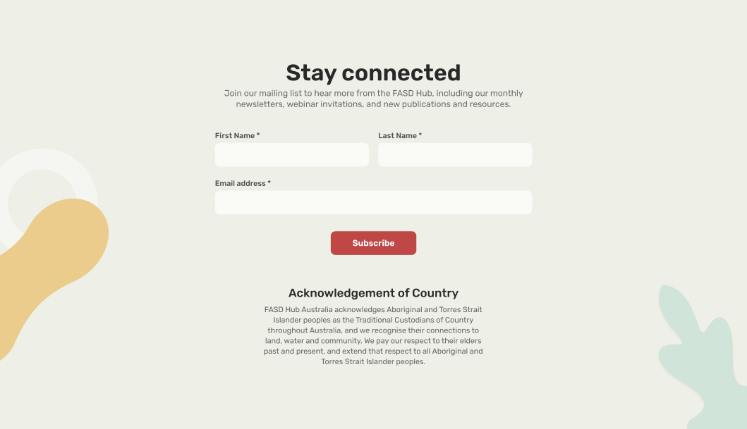

**The first thing to note is that the "Stay Connected" section is universal across the website. This means you only need to edit it in one place because it shows up almost the same on every page.**

## **—How to edit a section**

**Steps below:**

First, you need to go to the **Admin dashboard**. Then click on the **'Forms'** option. After that, the Forms page will open up in front of you, as shown in the screenshot below.

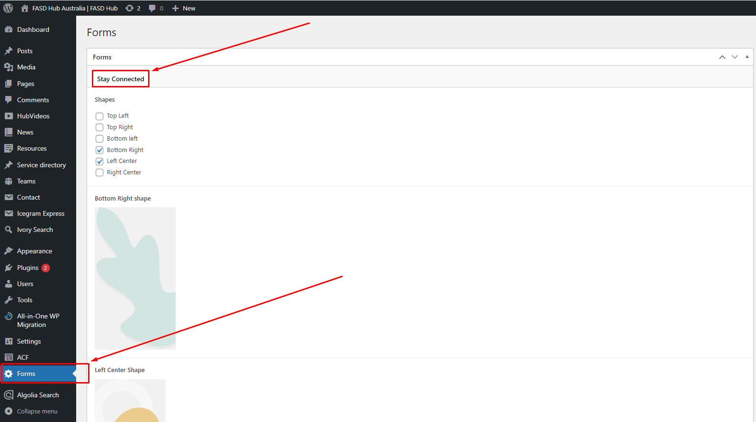

Now, you will be shown options to modify the section, from where you can edit the content as per your requirements, as shown in the screenshot below.

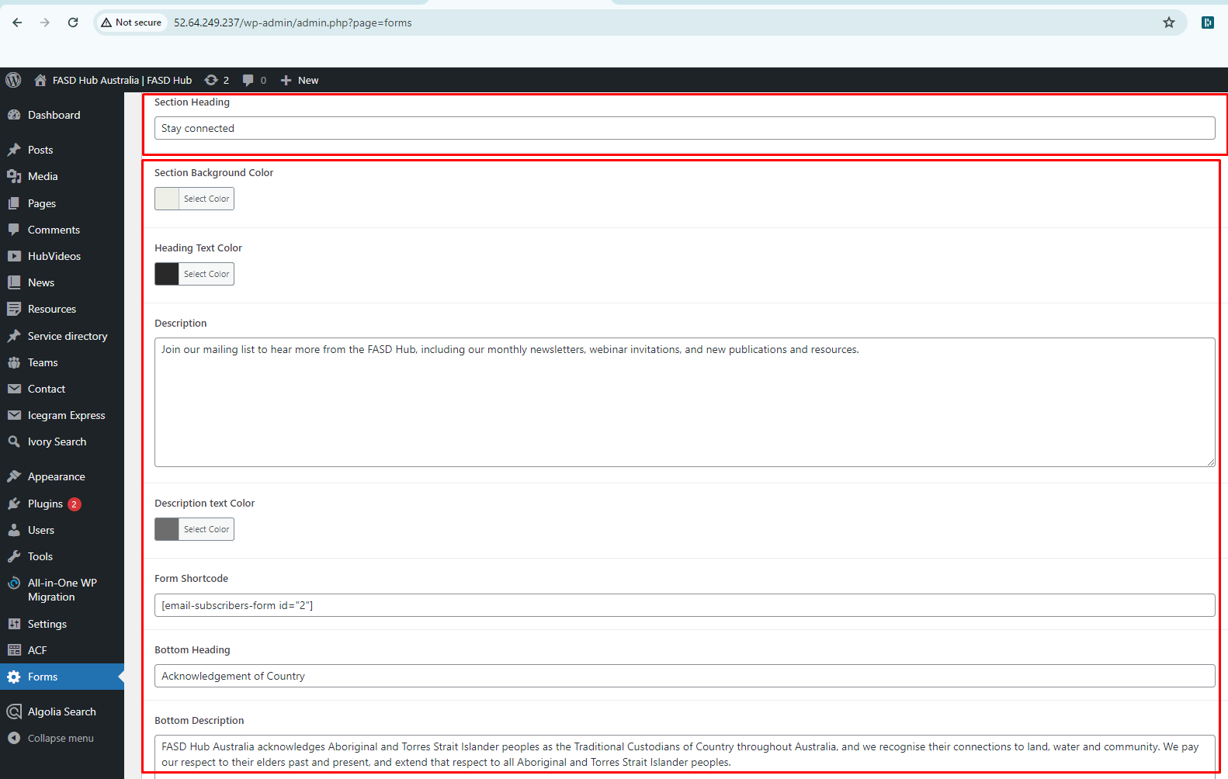

In this page, there is a field for Form Shortcode where the shortcode for the email subscribe form is placed, which has been added through a plugin. Please do not delete this shortcode & plugin, as shown in the screenshot below.

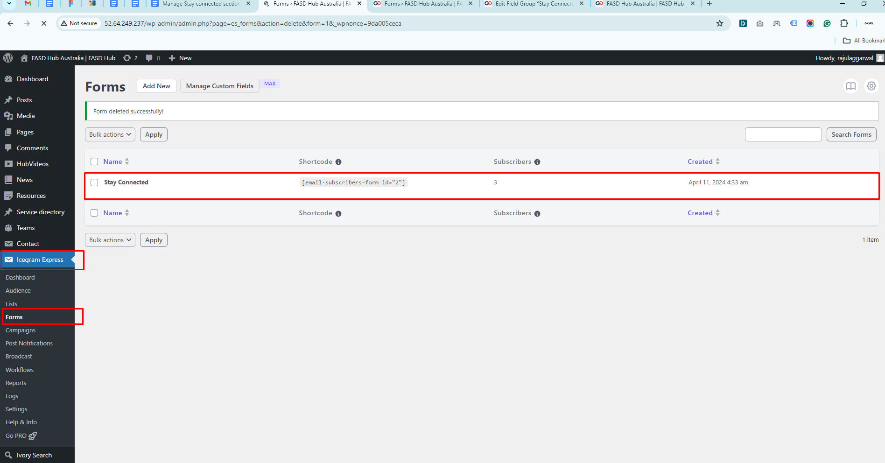

## **—How to Add a 'Stay Connected' Section to a Page**

**Steps below:**

On all pages, you will find an option in the right sidebar of the page to enable or disable this section. From there, you can add or remove this section. Whenever you create a new page, this option will be checked by default, so it will be shown. If you want to hide it, you will need to uncheck it, as shown in the screenshot below.



 